Exercises based on Exploropleth
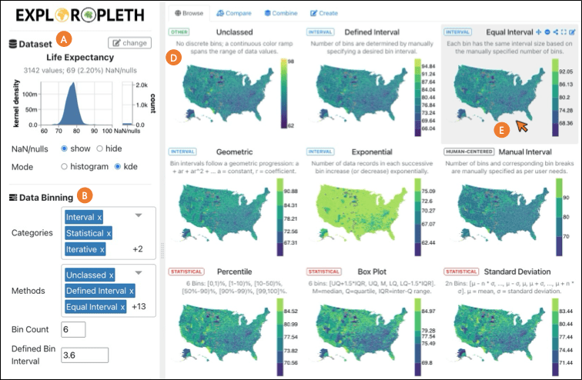

Objective
Exploropleth is a web-based geospatial visualization software which aims to help users explore a variety of data binning methods. You will learn how to use Exploropleth and develop insights regarding the different methods and features the software provides its users.
The software and resources can be accessed at https://exploropleth.github.io/ (click “Launch Tool”).
Take 15 mins: Gain familiarity with Exploropleth – Explore the different datasets and binning methods offered by the software. Pay close consideration to how each binning method affects the resulting visualization and how it impacts your perception of the grouping and spread of the data.

Part 1 – Data Binning
Answer the following questions related to binning methods below. You can use the “Browse” and “Compare” tabs in Exploropleth to help inform your answers.

- Below, describe similarities you see between different binning methods. In the answers, identify sets of similar methods and explain the similarities in how they construct their bins:
  - These [insert methods] are similar because [insert response].
  - These [insert methods] are similar because [insert response].
  - These [insert methods] are similar because [insert response].

- An anomaly is something that ‘sticks out’ or is much different than other entities. Can you find an anomaly in the dataset? What binning method helps you do this?

- What is log scale binning, and what is it helpful for?
Name one variable that would be useful to use with log scale, and one that would not be useful.
Useful variables:
Not Useful variables:

- Make a map with a diverging color scheme and make a second map with a sequential color scheme. For both, use quantile binning with 5 categories and keep the bins at the same breaks. Paste them side by side. Do they tell similar stories? Why or why not?

- Which binning method ‘promises’ a high level of variation in the data representation (i.e. a lot of presence from each of the different colors)?

- Go to the Box Plot tab or visit BinGuru. Think of how this tool would be useful for an “unmapped” (aspatial, or spatial but not mapped) dataset and write a case where you could use it.

Part 2 – Create your own map in the Create Tab.
- Go to the Create Tab. Find an indicator you are interested in (e.g. obesity, HIV rate, life expectancy, average years of schooling). Use natural breaks and take a screencap of the map.

[screencap here]

Part 3 – Critical thinking on ‘paint mode’ in the Create Tab.
- In the Create Tab, turn on ‘paint mode’ (ask if you can’t find it). Find a place or two on the map that you care about and want to have a narrative for it to fit into a ‘high’ or ‘low’ values of that indicator. Imagine you are trying to make this map to persuade a politician, policymaker, or community of your argument. Paint the map from Question 8 so it matches your personal arguments for that place and take a screencap.

[screencap here]
How are your two maps different? Was it ethical to change the map the way you did? Tell us what you did to make the change.

- Consider the six high-level categories of binning methods cited in the Narechania et al (Exploropleth, published in CaGIS 2025) reading in relation to the indicator you’re interested in. Contrive two realistic scenarios in which a unique category of binning method may be particularly effective (or ineffective) at advancing a chosen argument (for an audience). Your answer should touch upon the strengths (or weaknesses) of your categories in comparison to other options.

Scenario 1:

Scenario 2:

Extra – Resiliency
- Click on the “Combine” tab in Exploropleth and read the explanation regarding Resiliency before answering the following questions. Explain the ‘resiliency’ binning method in a nutshell, in your own words like you were explaining it to a friend (it’s tricky!).

- What are the inputs (not the data itself) to the resiliency algorithm?

- Name two indicators (variables) that come out of resiliency.

- Choose a dataset other than life expectancy, find one area that has high resiliency, and one with low resiliency. Screen cap your map and point out both areas. In terms of this map, what does it mean to have low or high resiliency?

[screencap here]

[writing here]

